

UNIVERSITY OF INFORMATION TECHNOLOGY – VNU-HCM

**FACULTY OF COMPUTER NETWORKS AND COMMUNICATIONS**

2. Dynamic Routing

NETWORKING TECHNOLOGIES– v1.2025

**PHỤC VỤ MỤC ĐÍCH GIÁO DỤC**

FOR EDUCATIONAL PURPOSE ONLY

Student Name: Trần Ngọc Bá Duy

Student ID: 24560039

# OVERVIEW

## Learning objective

The learning objective of this lab is to understand how to dynamically exchange routing information between routers. Students will configure, observe, and troubleshoot the Routing Information Protocol1 (RIP) and the Open Shortest Path First2 (OSPF).

## Practice Environment

* + - Practicing with physical networking devices
    - Cisco Packet Tracer

1 Distance Vector Routing algorithm

2 Link State Routing algorithm

# LAB TASKS

## Dynamic Routing theory

Before practicing, let’s find the answer to the following questions:

1. What is the difference between Classful and Classless?
2. We usually use the command **no auto-summary** when configuring RIP. Why do we need to use this command? What will happen if we configure RIPv2 without that command?
3. What do the C, L, and R (shown in Figure 1) stand for?

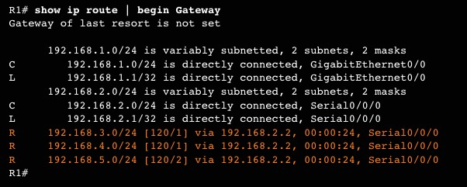

* 1. **Dynamic Routing – RIP**

*Figure 1: Example of the routing table*

**2**

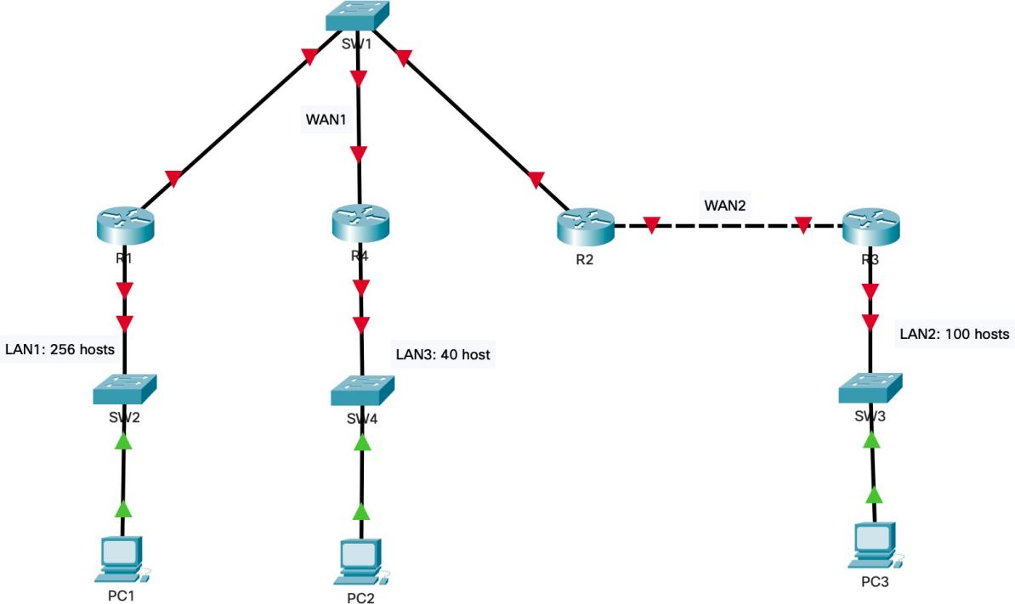

*Figure 2: The topology diagram for Task 2*

**3**

In this task, you will learn how to configure a small network with dynamic routing algorithms.

You are giving a topology diagram as shown in the figure above and network address ***172.16.0.0/16***.

**Requirements:**

1. You need to divide the given network into suitable subnets for LAN networks and WAN networks. Then, fill out the result in ***Subnetting table*** (refer to Table 1). The VLSM method is recommended.
2. Set the hostname on all devices to match the topology diagram.
3. Set Banner Motd as ***“Warning: Authorized Access Only on Router Rx”*** (Rx is the name of Routers) on all routes.
4. Configure IP addresses and masks on all devices. You need to fill out this information in the ***IP Assignment table*** (refer to Table 2).
5. Configure the routers to run RIPv2.
6. Enable Tenet Remote Access on all routers.

*You should frequently copy the Running-configuration to the Startup-configuration to avoid configuration losing when the device unexpectedly reboots.*

*Table 1: Example of Subnetting Table*

|  |  |  |  |
| --- | --- | --- | --- |
| **Subnet** | **Network Address/CIDR** | **First IP Address** | **Broadcast Address** |
| **LAN1** | 172.16.0.0 | 172.16.0.1 | 172.16.1.255 |
| **LAN2** | 172.16.2.0 | 172.16.2.1 | 172.16.2.127 |
| **LAN3** | 172.16.2.128 | 172.16.2.129 | 172.16.2.191 |
| **WAN1** | 172.16.2.192 | 172.16.2.193 | 172.16.2.199 |
| **WAN2** | 172.16.2.200 | 172.16.2.201 | 172.16.2.203 |

*Table 2: Example of addressing table*

|  |  |  |  |  |
| --- | --- | --- | --- | --- |
| **Device** | **Interface** | **IP Address** | **Subnet Mask** | **Default Gateway** |
| **R1** | G0/0 | 172.16.0.1 | 255.255.254.0 |  |
| G0/1 | 172.16.2.193 | 255.255.255.248 |  |
| **R2** | G0/0 | 172.16.2.201 | 255.255.255.252 |  |
| G0/1 | 172.16.2.195 | 255.255.255.248 |  |

**4**

|  |  |  |  |  |
| --- | --- | --- | --- | --- |
| **R3** | G0/0 | 172.16.2.1 | 255.255.255.128 |  |
| G0/1 | 172.16.2.202 | 255.255.255.252 |  |
| **R4** | G0/0 | 172.16.2.129 | 255.255.255.192 |  |
| G0/1 | 172.16.2.194 | 255.255.255.248 |  |
| **PC1** | NIC | 172.16.0.2 | 255.255.254.0 | 172.16.0.1 |
| **PC2** | NIC | 172.16.2.130 | 255.255.255.192 | 172.16.2.129 |
| **PC3** | NIC | 172.16.2.2 | 255.255.255.128 | 172.16.2.1 |

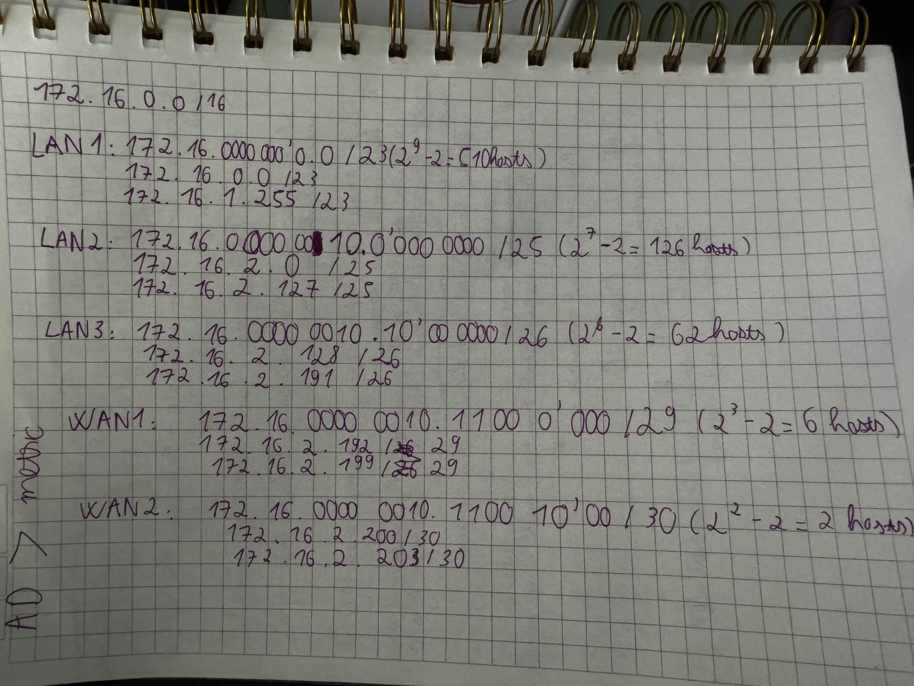

Password uit

## Dynamic routing – OSPF

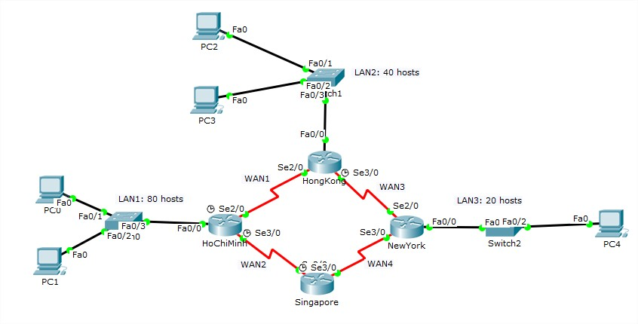*Figure 3: The topology diagram for Task 3*

**Requirements:** You are given the network topology as shown in the figure above and network address ***172.16.0.0/16*** (with X standing for your group’s ID).

1. You need to divide the allocated network into suitable subnets for LAN and WAN networks. Then, fill out the result in ***Subnetting table*** (refer to Table 1). The VLSM method is recommended.
2. Set the hostname on all devices.
3. Set Banner Motd as ***“Warning: Authorized Access Only on Router Rx”*** (Rx is the name of Routers) on all Routes.
4. Assign the IP address for all necessary interfaces of devices. You need to fill out this information in the ***IP Assignment table*** (refer to Table 2).
5. Configure OSPF routing to all routers so that all hosts among networks can communicate with each other.

*Please note that you should frequently save the Running-configuration to the Startup- configuration in case of unexpected device rebooting.*

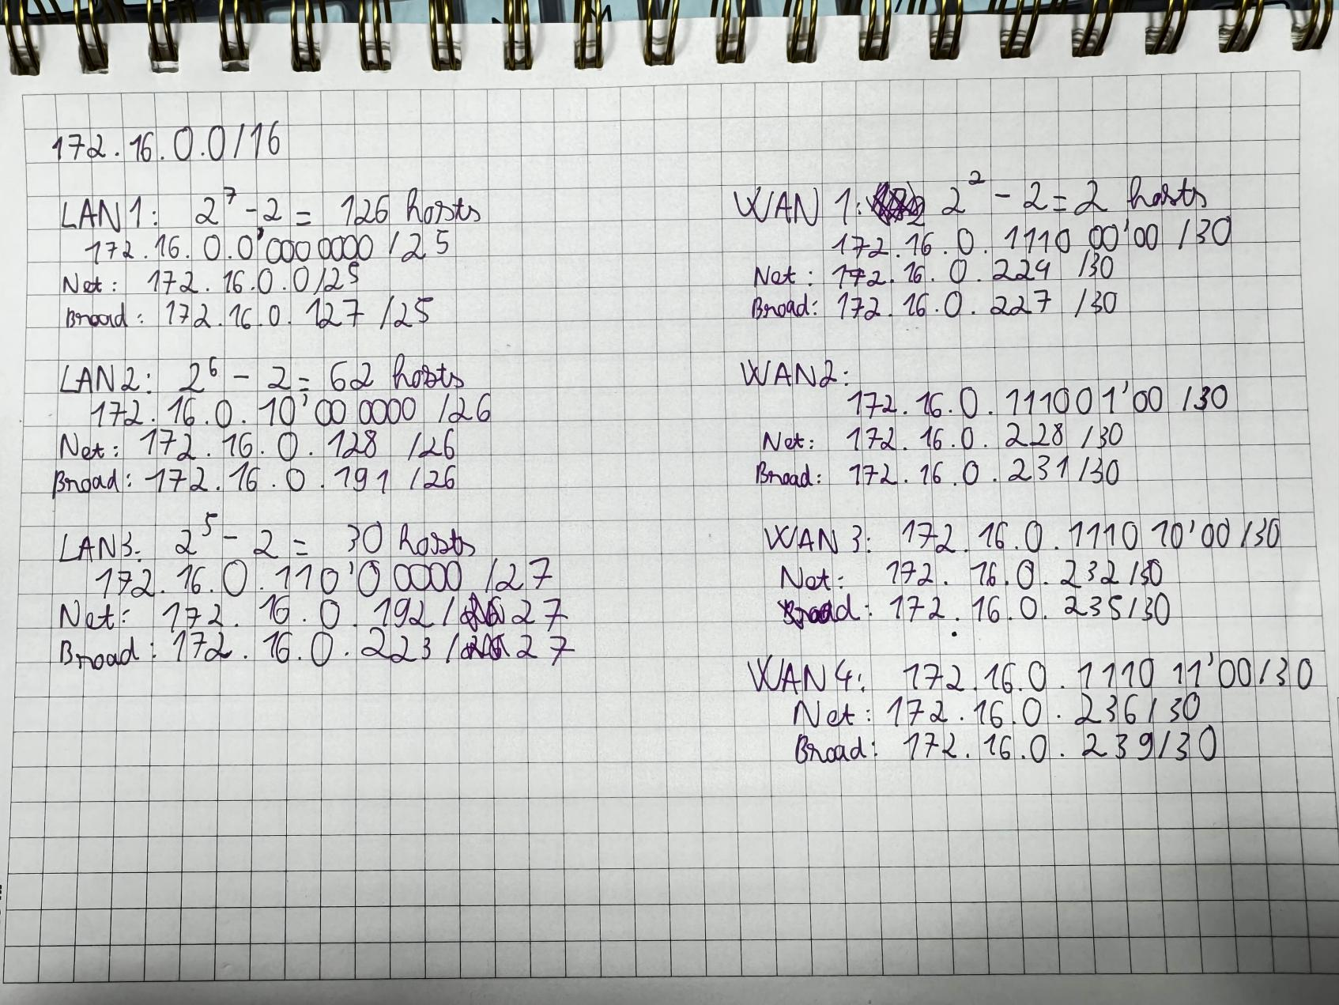

|  |  |  |  |
| --- | --- | --- | --- |
| **Subnet** | **Network Address/CIDR** | **First IP Address** | **Broadcast Address** |
| **LAN1** | 172.16.0.0 | 172.16.0.1 | 172.16.0.127 |
| **LAN2** | 172.16.0.128 | 172.16.0.129 | 172.16.0.191 |
| **LAN3** | 172.16.0.192 | 172.16.0.193 | 172.16.0.223 |
| **WAN1** | 172.16.0.224 | 172.16.0.225 | 172.16.0.227 |
| **WAN2** | 172.16.0.228 | 172.16.0.229 | 172.16.0.231 |
| **WAN3** | 172.16.0.232 | 172.16.0.233 | 172.16.0.235 |
| **WAN4** | 172.16.0.236 | 172.16.0.237 | 172.16.239 |

|  |  |  |  |  |
| --- | --- | --- | --- | --- |
| **Device** | **Interface** | **IP Address** | **Subnet Mask** | **Default Gateway** |
| **HO CHI MINH** | S0/0/0 | 172.16.0.225 | 255.255.255.252 |  |
| S0/0/1 | 172.16.0.229 | 255.255.255.252 |  |
| G0/0 | 172.16.0.1 | 255.255.255.128 |  |
| **SINGAPORE** | S0/0/0 | 172.16.0.237 | 255.255.255.252 |  |
| S0/0/1 | 172.16.0.230 | 255.255.255.252 |  |
| **NEW YORK** | S0/0/0 | 172.16.0.238 | 255.255.255.252 |  |
| S0/0/1 | 172.16.0.233 | 255.255.255.252 |  |
| G0/0 | 172.16.0.193 | 255.255.255.224 |  |
| **HONG KONG** | S0/0/0 | 172.16.0.226 | 255.255.255.252 |  |
| S0/0/1 | 172.16.0.234 | 255.255.255.252 |  |
| G0/0 | 172.16.0.129 | 255.255.255.192 |  |
| **PC0** | NIC | 172.16.0.2 | 255.255.255.128 | 172.16.0.1 |
| **PC1** | NIC | 172.16.0.3 | 255.255.255.128 | 172.16.0.1 |
| **PC2** | NIC | 172.16.0.130 | 255.255.255.192 | 172.16.0.129 |
| **PC3** | NIC | 172.16.0.131 | 255.255.255.192 | 172.16.0.129 |
| **PC4** | NIC | 172.16.0.194 | 255.255.255.224 | 172.16.0.193 |

**4**

**5**

# REQUIREMENTS

You are expected to complete all tasks in section B (Lab tasks). Advanced tasks are optional, and you could get bonus points for completing those tasks.

Your submission must meet the following requirements:

* You need to submit a **detailed lab report in .docx** *(Word Document)* format,

**using the report template** provided on the UIT Courses website.

* A report written in English is required.
* When it comes to **programming tasks** *(require you to write an application or script),* please attach all source-code and executable files (if any) in your submission. Please also list the important code snippets followed by explanations and screenshots when running your application in your report. Simply attaching code without any explanation will not receive points.
* Submit work you are proud of – don’t be sloppy and lazy!

Your submissions must be your own. You are free to discuss with other classmates to find the solution. However, copying reports is prohibited, even if only a part of your report. Both reports of the owner and the copier will be rejected. Please remember to cite any source of the material (website, book,…) that influences your solution.

**Notice:** Combine your lab report and all related files into a single **ZIP file (.zip)**, name it as follow:

***StudentID _ReportLabX.zip***